1. The eXclusive NOR gate, written XNOR, is equivalent to an XOR followed by an inverter.
   1. Draw the logic symbol for a two input XNOR gate.

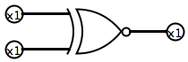

* 1. Construct its truth table.

|  |  |  |
| --- | --- | --- |
| **Input A** | **Input B** | **Output** |
| 0 | 0 | 1 |
| 0 | 1 | 0 |
| 1 | 0 | 0 |
| 1 | 1 | 1 |

* 1. The XNOR is also called a ‘comparator’, why?
* It’s called a comparator because its output is 1 only if its two inputs are equal.

1. Identify each gate in Fig. 10.63 as one of the following:
2. An AND gate, 2) an OR gate, 3) a NAND gate, 4) a NOR gat

* a = NAND
* b = NOR
* c = AND
* d = OR

1. Write the Boolean expressions for the logic diagram in Fig 10.62.
   1. F =
   2. F =
   3. F =
2. 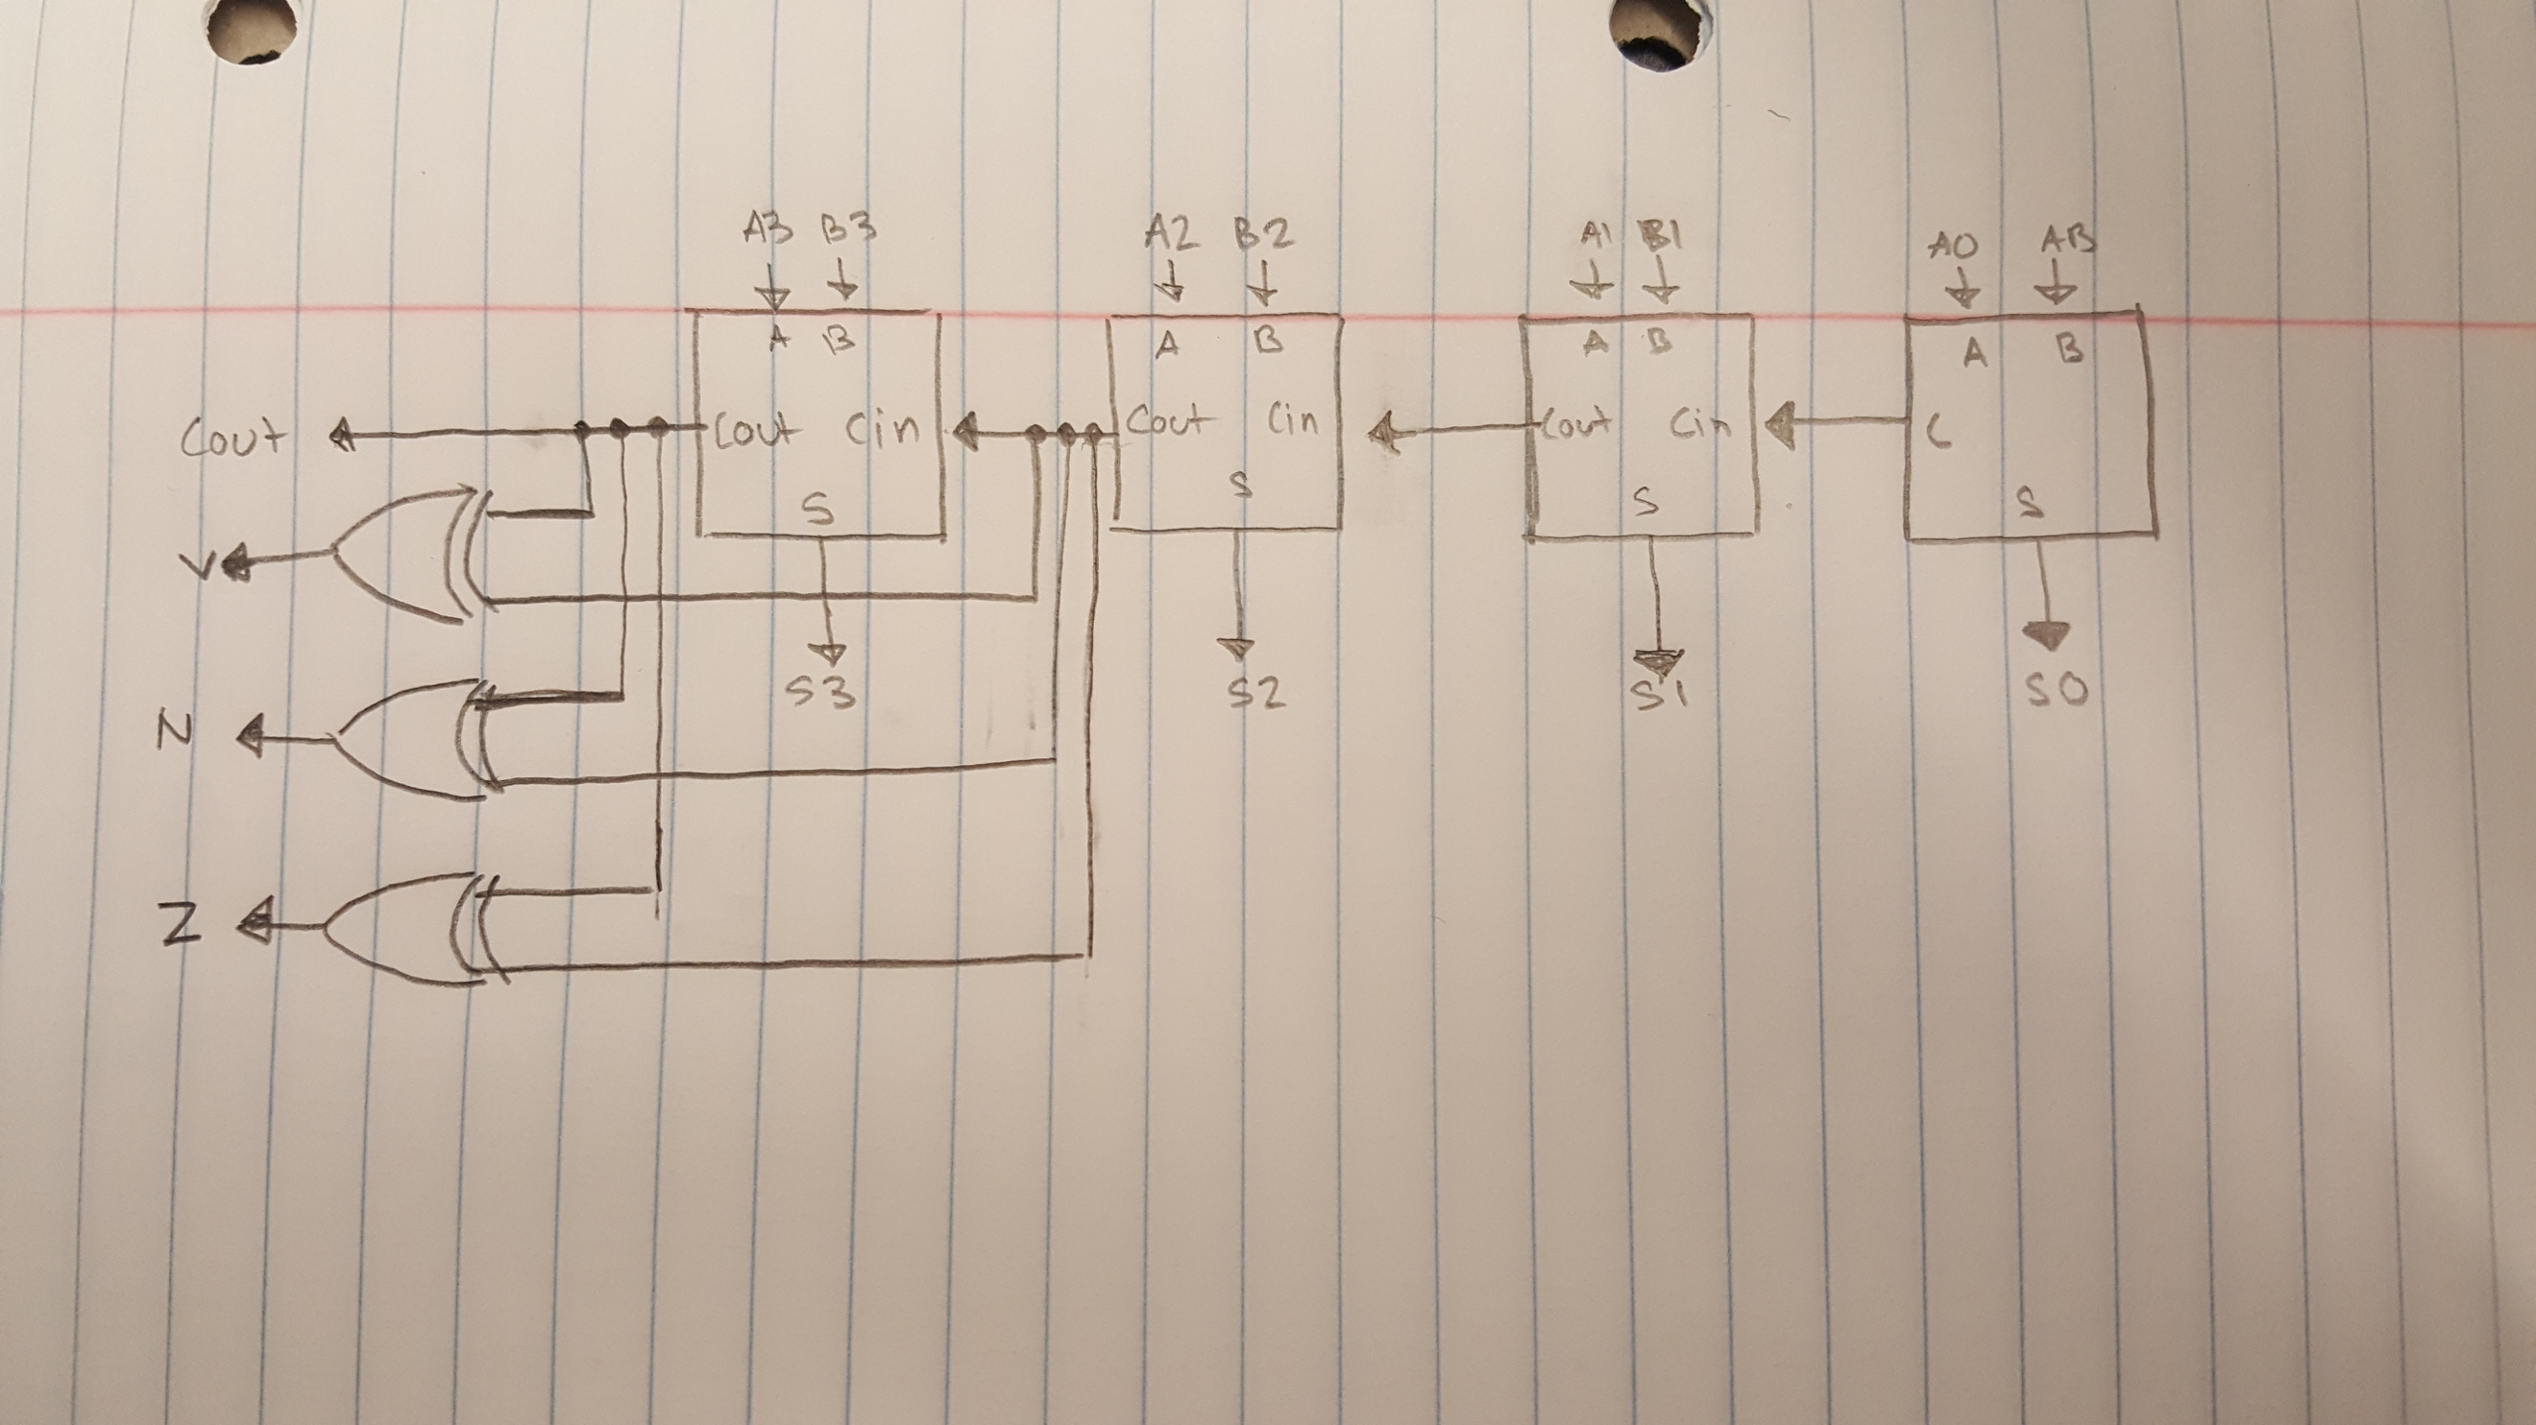Modify Fig 10.52(b) to provide two additional outputs, one for the ‘N’ bit and one for the ‘Z’ bit.
3. Implement the following logical units (LU’s) for the PEP/8 ALU
4. LU5, A **AND** B
5. LU7, A **OR** B
6. LU9, A **XOR** B

a. 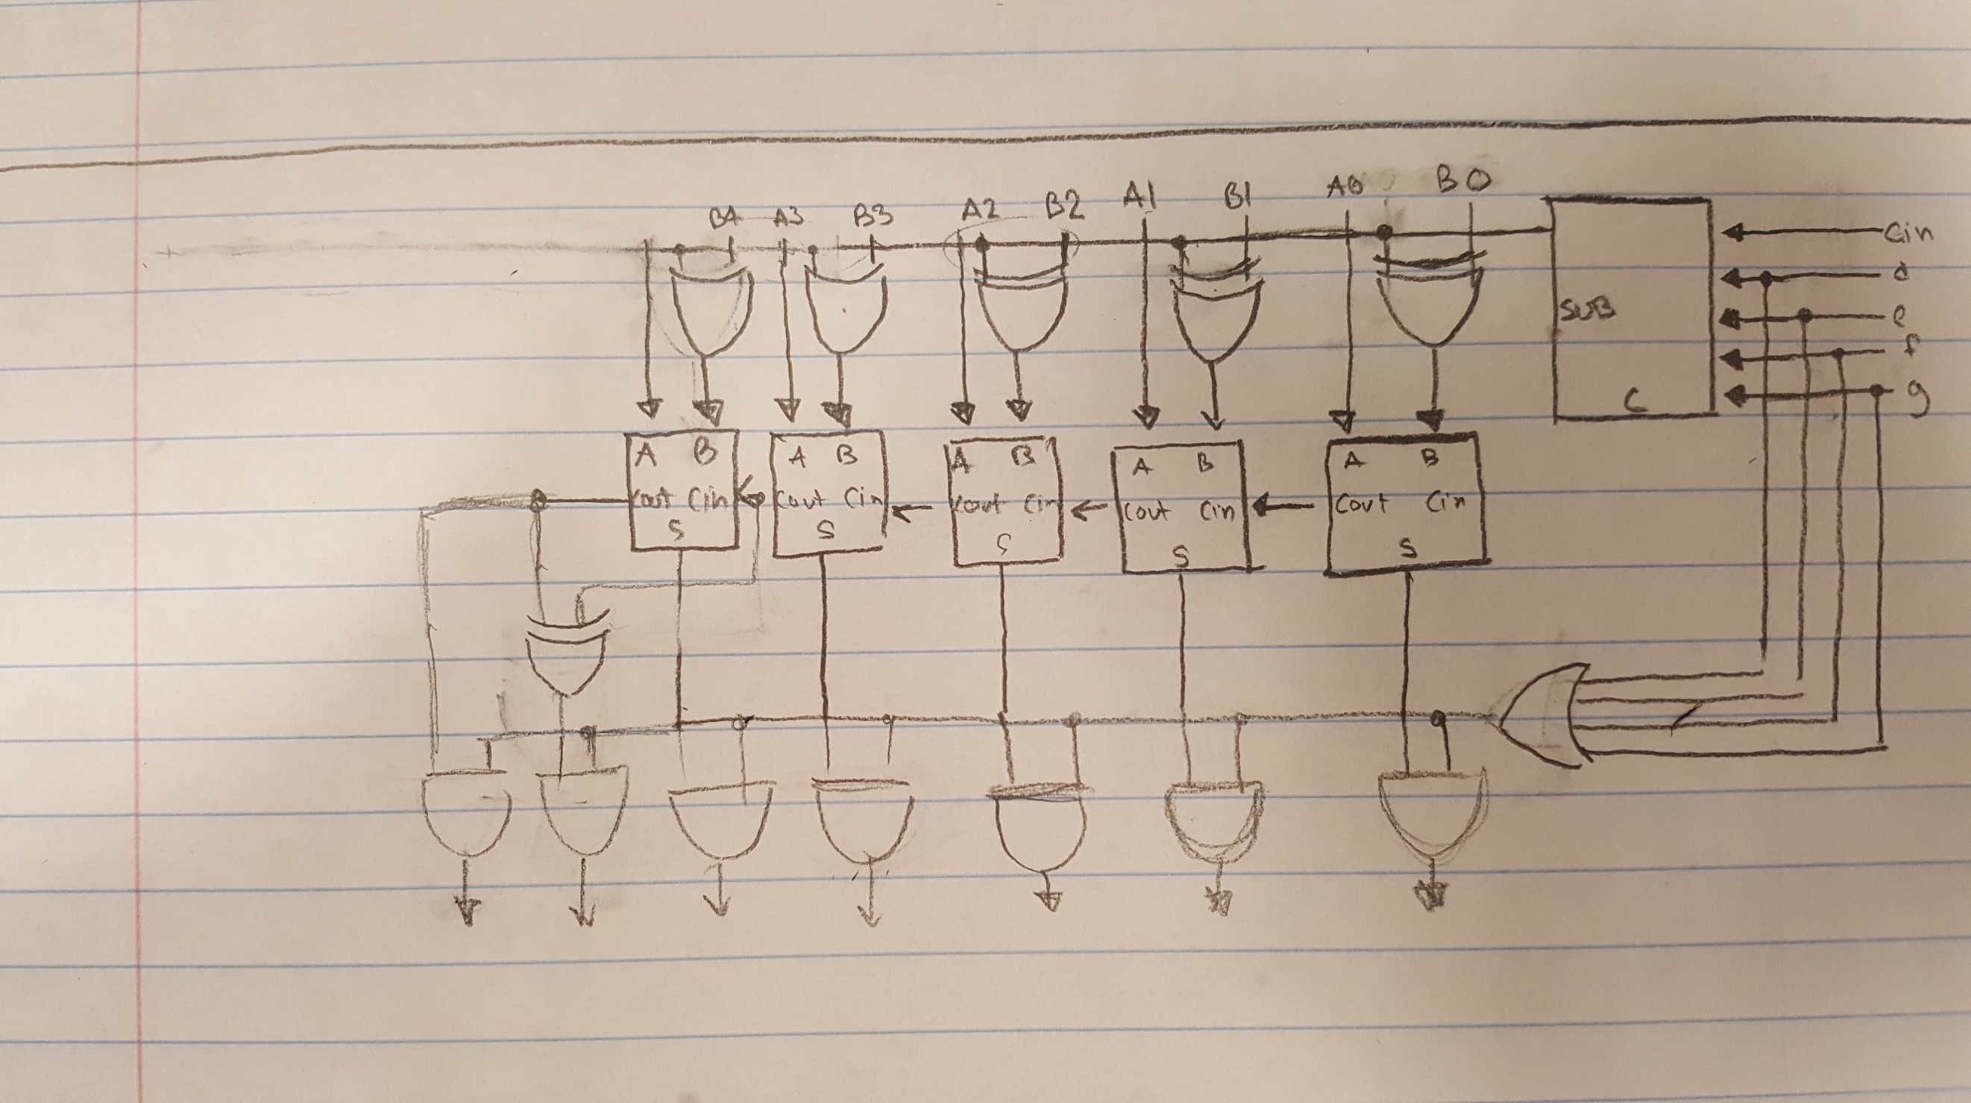

b.

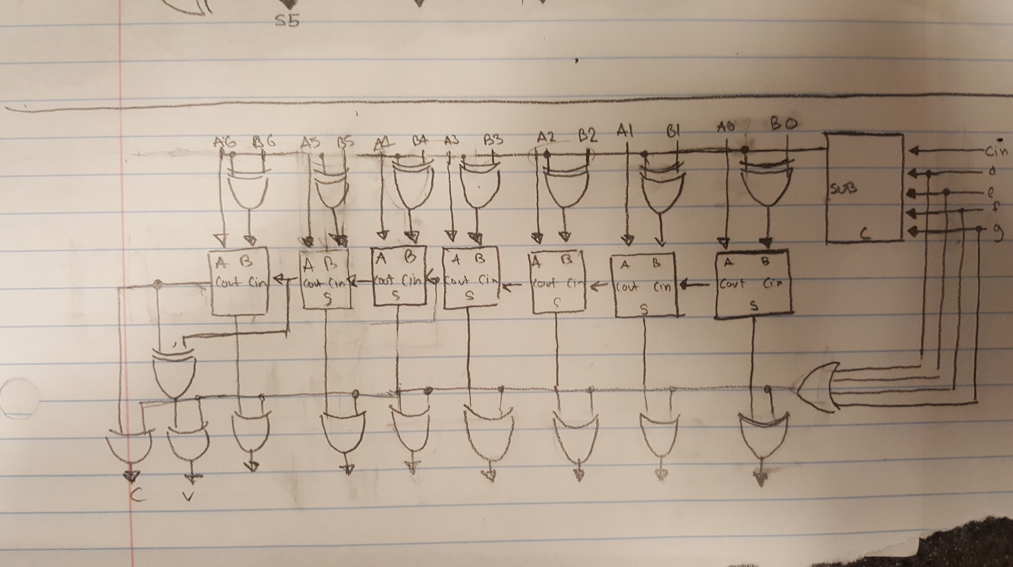

c.

